2016 Gwen Jorgensen Scholarship Information

About: The intent of the scholarship is to help junior (draft-legal or Paralympic) triathletes pursue excellence. This year (2016) one or multiple scholarships will be awarded. A total of over $25,000, along with mentoring from Gwen Jorgensen, will be awarded.

Who can apply: Any male or female can apply (athletes, coaches, race promoters, paratriathletes, etc.) but funds must be used for draft-legal or Paralympic triathletes under the age of 19 on December 31st, 2016 (example: a junior athlete could use funds for travel/equipment, a coach could use funds for a coach-led daily performance environment with junior triathletes, a race promoter could use funds for a junior draft-legal triathlon race or camp, etc.).

Special consideration will be given to the following categories:
- Financial need
- Innovative/creative application of funds
- Applicant’s passion for draft-legal triathlon

Important Dates:
Application deadline: September 21st, 2016
Scholarship awarded: November 29th, 2016

Please fill out the form on the next page and email it to gwenjorgensenscholarship@gmail.com

Special thanks to the USA Triathlon Foundation, NYAC, and ROKA for their financial support.

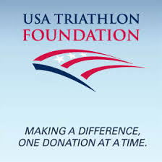
2016 Gwen Jorgensen Scholarship Application

Please email this form when completed to GwenJorgensenScholarship@gmail.com

What is your name?

What is your gender?

What will be your age on December 31, 2016?

What is your hometown and state?

What is your country?

What is your mailing address?

What is your email address?

What is your cell phone number? Please include international codes.

What was your best race result in a draft-legal triathlon? Include name of race, year, and place.

In 500 words or less, please explain why you should be chosen for the Gwen Jorgensen scholarship and how the funds will be used.

